> **12+4-5;**



> **2^10;**



> **sin(0.1);**



> **(a+b)(a-b);**



> **y:=x->3*(x^3)+2*(x^2)-5;**

> **diff(y(x),x);**





> **y:=x->sqrt(1+(x^4));**



> **diff(y(x),x);**



> **y:=x->exp(x)*sin(x)*cos(x);**



> **diff(y(x),x);**



> **int(3*(x^3)+2*(x^2)-5,x=0..1);**



> **int(1/(x^2),x=0..infinity);**



> **int(exp(-(x^2)),x=-infinity..infinity);**



> **limit(sin(x)/x,x=0);**



> **limit((x^3+3*(x^2)-5)/(2*(x^3)-7*x),x=infinity);**

> **limit((cos(x)+1)/(x-Pi),x=Pi);**





> **f:=x->exp(-x)-1;**

> **with(plots):**



Warning, the name changecoords has been redefined

> **plot(f(x),x=-2..2);**

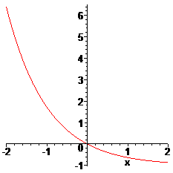

> **f:=x->((200*exp(r*x))/(2*(exp(r*x)-1)+100));**



> **r:=0.5;**



> **\with(plots);**



> **plot(f(x),x=0..50);**

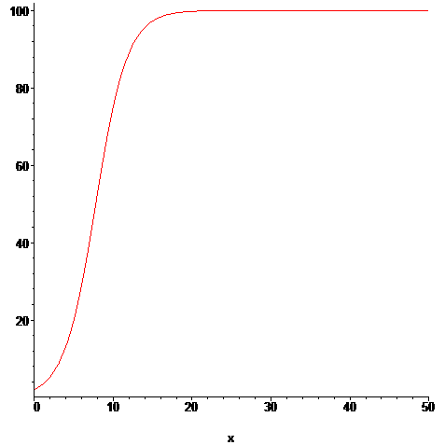

> **f:=x->x*sin(1/x);**



> **plot(f(x),x=-3..3);**

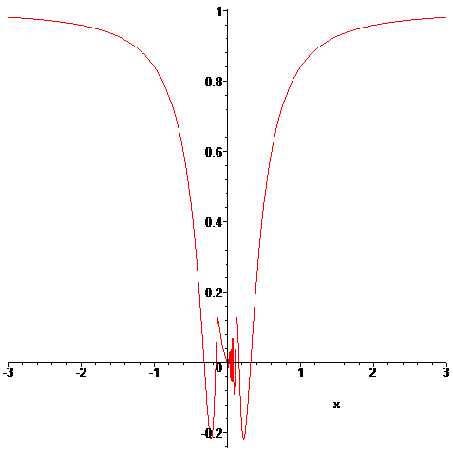

>

> **x:=t->(1-cos(t))*cos(t);**



> **y:=t->(1-cos(t))*sin(t);**



> **plot([x(t),y(t),t=0..2*Pi]);**

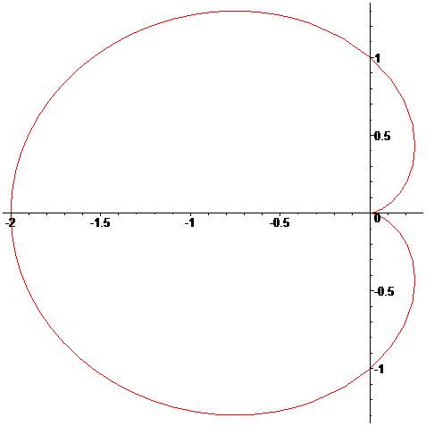

> **x:=t->sin(3*t)*cos(t);**



> **y:=t->sin(3*t)*sin(t);**



> **plot([x(t),y(t),t=0..2*Pi]);**

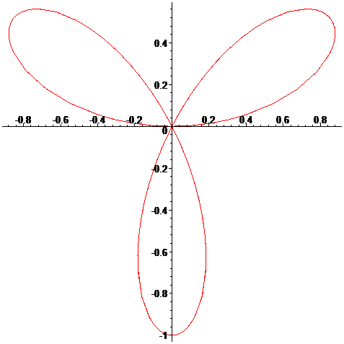

> **x:=t->t-sin(t);**



> **y:=t->1-cos(t);**



> **plot([x(t),y(t),t=0..6*Pi]);**

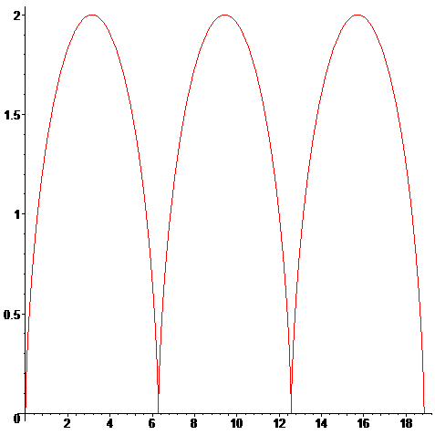

> **f:=(t,s)->1-(s*cos(4*t)*cos(t))/sqrt(1-(s^2)*(cos(4*t))^2*(sin(t))^2);**



> **x:=(t,s)->f(t-Pi/2,s);**



> **y:=(t,s)->f(t,s);**



> **s:=0.5;**



> **plot([x(t,s),y(t,s),t=0..2*Pi]);**

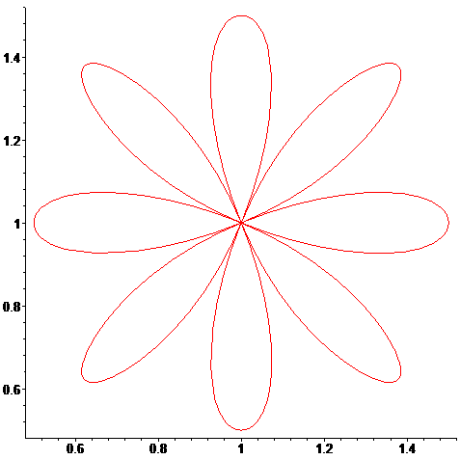

> **plot([[x(t,i/10),y(t,i/10),t=0..2*Pi]$i=1..10]);**

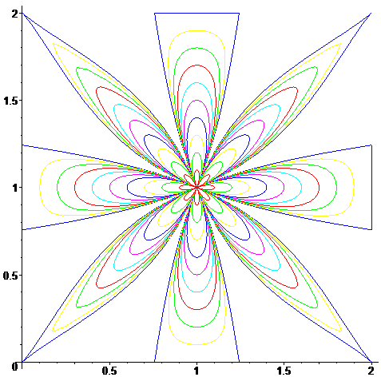

> **with(plots):**

> **implicitplot(x^2+y^2-2*x-4*y+4=0,x=0..3,y=0..3);**

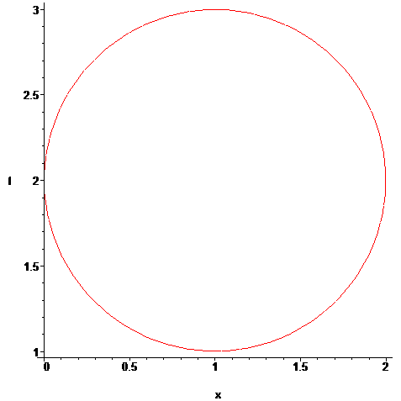

> **implicitplot(x^2-2*x*y-y^2=1,x=-1..1,y=-1..1);**

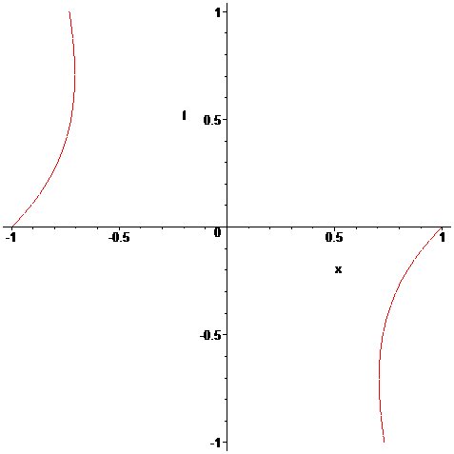

>

> **z:=(x,y)->4*(x^2)*exp(y)-2*(x^4)-exp(4*y);**



> **plot3d(z(x,y),x=-3..3,y=-1..1);**

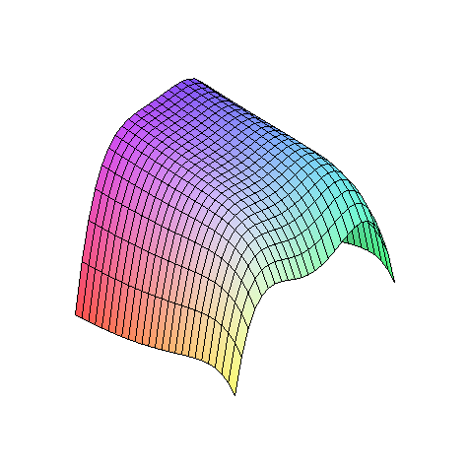

> **z:=(x,y)->4*(x^2)-y^2;**



> **plot3d(z(x,y),x=-100..100,y=-100..100);**

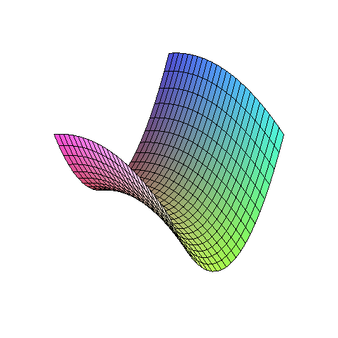

> **with(linalg);**



> **A:=matrix([[1,2,-1],[0,1,0],[3,-1,2]]);**



> **B:=matrix([[1,2,3],[1,1,2],[2,1,1]]);**



> **C:=matrix([[2,1,1],[0,1,-1],[4,2,2]]);**



> **evalm(2*A-B);**



> **evalm(B^(-1));**



> **eigenvals(C);**



> **eigenvects(C);**

